PESTools – A Python toolkit for processing PEST-related information

Evan G. Christianson¹, Andrew T. Leaf²
¹Barr Engineering, echristianson@barr.com, Minneapolis, MN, USA
²USGS – Wisconsin Water Science Center, aleaf@usgs.gov, Madison, WI, USA

ABSTRACT

PESTools is an open-source Python package for processing and visualizing information associated with the parameter estimation software PEST. While PEST output can be reformatted for post-processing in spreadsheets or other menu-driven software packages, this approach can be error-prone and time-consuming. Managing information from highly parameterized models with thousands of parameters and observations presents additional challenges. PESTools consists of a set of Python object classes to facilitate efficient processing and visualization of PEST-related information. Processing and visualization of observation residuals, objective function contributions, parameter and observation sensitivities, parameter correlation and identifiability, and other common PEST outputs have been implemented. The use of dataframe objects (pandas Python package) facilitates rapid slicing and querying of large datasets, as well as the incorporation of ancillary information such as observation locations and times and measurement types. PESTools’ object methods can be easily scripted with concise code, or alternatively, the use of IPython notebooks allows for live interaction with the information. PESTools is designed to not only streamline workflows, but also provide deeper insight into model behavior, enhance troubleshooting, and improve transparency in the calibration process

INTRODUCTION

In recent years the PEST software suite (Doherty, 2010a: Doherty, 2010b) has become the industry standard for calibrating groundwater flow models and evaluating uncertainty in their predictions. PEST has many advantages, including the ability to robustly handle highly parameterized models with thousands of parameters and observations, as well as numerous utility programs to perform ancillary analyses and facilitate use with popular modeling software such as MODFLOW. However, there are also many challenges in using PEST, especially in the highly parameterized context. Calibration of highly parameterized models typically requires managing large volumes of information spread across numerous input and output files. This information may provide valuable insight, but can be difficult or impossible to effectively visualize without custom programming. PESTools aims to provide a central platform for managing and visualizing this information, which minimizes the number of intermediate files and custom code required for parameter estimation workflows.

DEMONSTRATION

PESTools is designed with flexibility in mind. There are several ways to access and process data through Python object classes, allowing interactive exploration or simple but customizable scripting. PESTools stores and/or returns PEST related information in Python dictionaries, pandas dataframes (http://pandas.pydata.org/), and Matplotlib plots (http://matplotlib.org/). These data structures allow the user to easily query and review information or customize visualizations beyond the methods included in PESTools.

Some examples of PESTools’ capabilities are presented below, including the code (indicated by courier font) used to generate the tables and figures. In most instances only one or two lines of code are needed to quickly generate useful output. Additional documentation, example datasets, and interactive tutorials using IPython notebooks (http://ipython.org/notebook.html) are available on the project webpage at https://github.com/PESTools.

At the top level of PESTools is the Pest class. The Pest class is created by providing the path and base name of a PEST run.

example = pestools.Pest(r'../cc/Columbia')

From the Pest class the user has access to numerous PEST related inputs and outputs, most commonly returned in the form of a pandas dataframe.

example.parameter_data

Table 1. Parameter data section of a PEST control file presented as a pandas dataframe. Per pandas conventions the middle section of the dataframe are excluded from view but are accessible using standard pandas methods.

example.observation_data
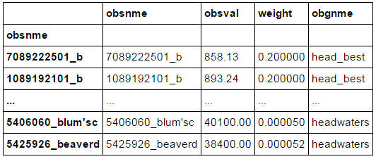
Table 2. Observation data section of a PEST control file presented as a pandas dataframe.

Following a PEST run, residual information can be read in, from a single .res file, or set of.rei files containing residual information by iteration. Ancillary observation information such as spatial coordiantes, date/time, or measurement type can be read in from an observation information file.

residuals = example.res('../cc/columbia_svda.rei.16', obs_info_file='../cc/observation_locations.csv')

Numerous plotting options are available for residual information. Residual information can be visualized by group (as defined in the PEST control file or by alternative grouping in the observation information file).

residuals.plot_hexbin(['head_fair', 'wcrs1'], title='Fair Heads', print_stats=['Mean', 'MAE', 'RMSE'])
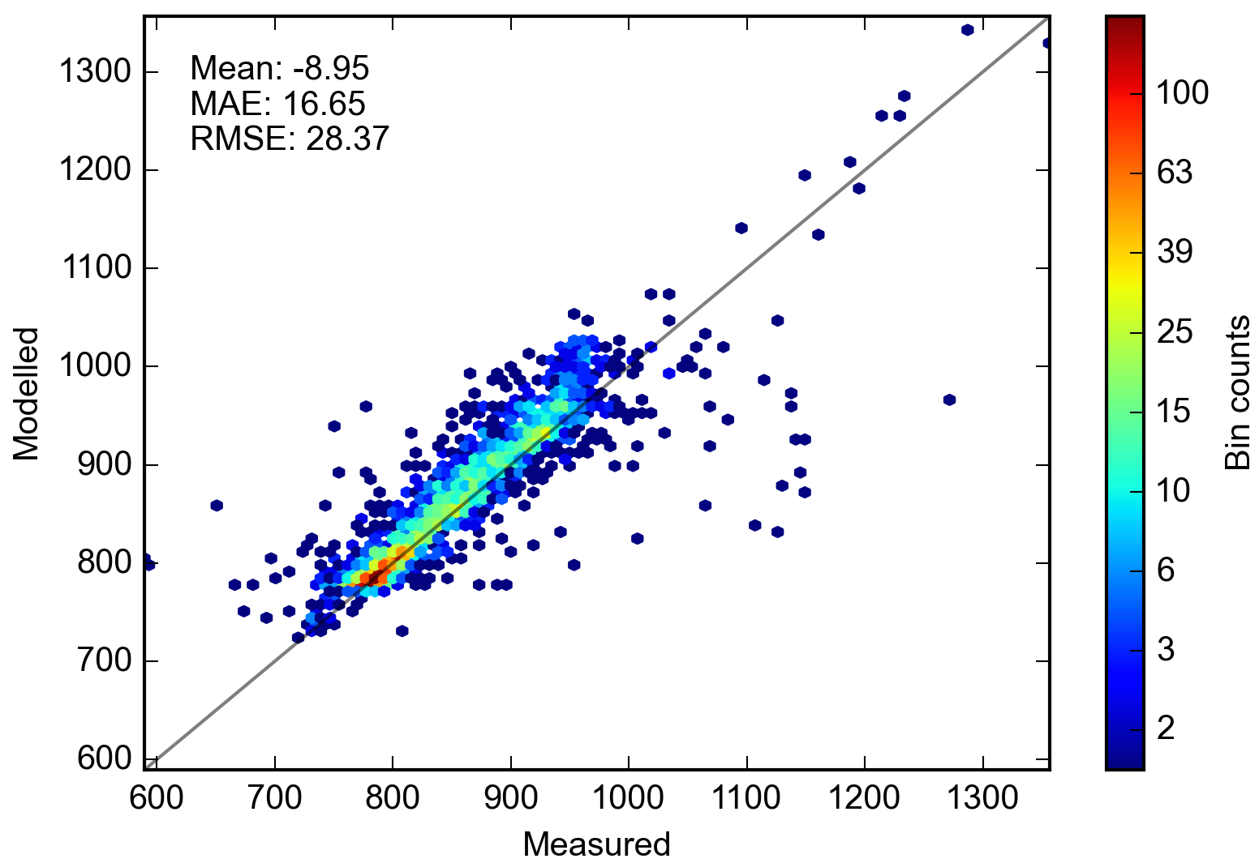
Figure 1. Plot of measured vs modelled values in the form of a hexbin plot. Hexbin plots are a 2D histogram; the color of each hexagon indicates the number of observations that fall within the space occupied by the hexagon. Warmer colors indicate more observations. Hexbin plots are useful when observations number in the thousands.

residuals.plot_hist(groupinfo=['head_best', 'head_good', 'head_fair', 'head_poor'], color='k')
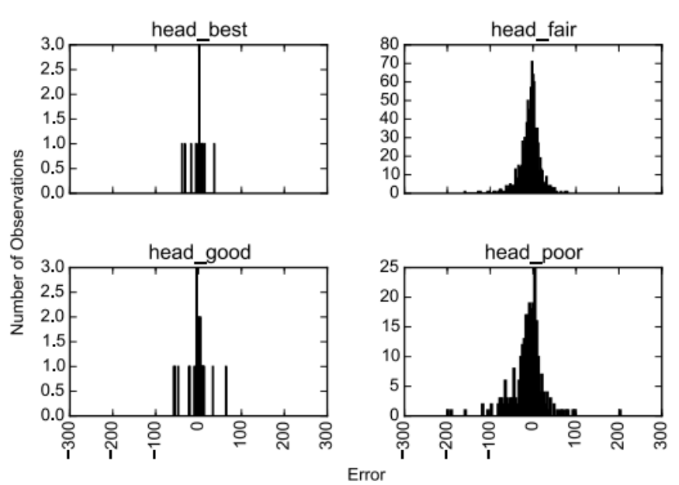

Figure 2. Histograms of residuals. Each histogram represents an individual observation group.

PESTools uses the binary Jacobian matrix writen by PEST and the weights recorded in the residuals file to calculate parameter sensitivities. Sensitivities can be recalculated with specific observations, or observation groups, removed.

parsen = pestools.ParSen(r'../cc/Columbia', drop_regul=True)
parsen.plot(n=20)

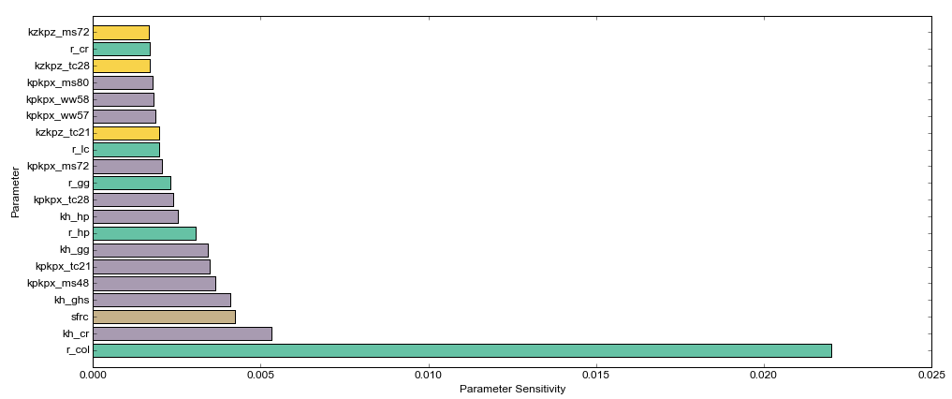
Figure 3. Plot of the 20 most sensitive parameters. Each color indicates a separate parameter group as defined in the PEST control file.

The Cor class of PESTools handles calculation and plotting of parameter correlations.

cor = example.cor
cor.plot_heatmap(parlist=['kpkpx_tc2', 'kpkpx_tc34', 'kpkpx_tc21', 'kv_w', 'wr_drnc', 'kzkpz_tc47', 'kv_lo', 'sfrc', 'r_col'])

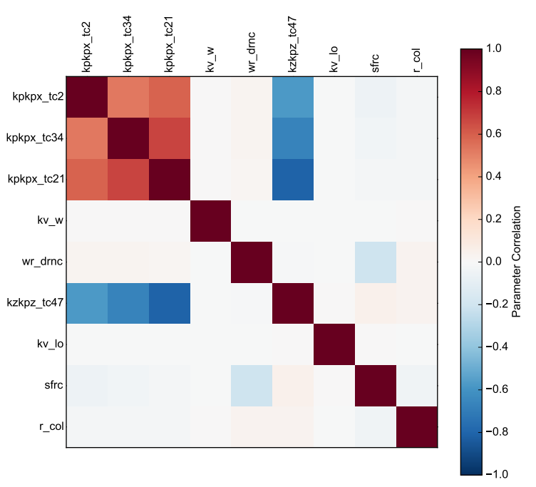
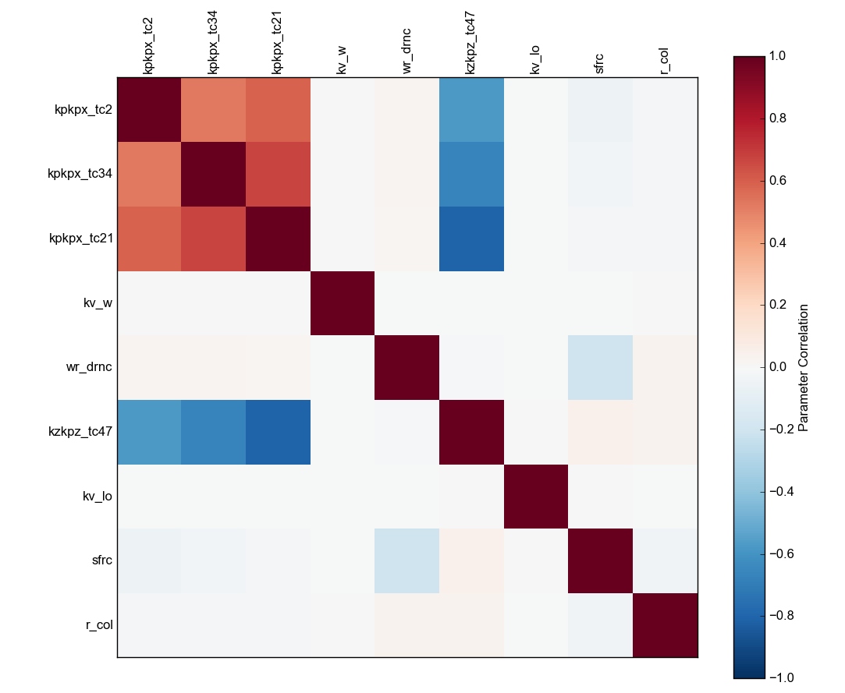

Figure 4. Heatmap of parameter correlation values for a select number of parameters.

The Identpar class produces visualizations of parameter identifiability (Doherty and Hunt, 2009), a qualitative indicator that describes the extent to which individual parameters are constrained by the observation data. In comparison to parameter sensitivity, identifiability is advantageous in that it accounts for both parameter sensitivity and correlation between parameters. PESTools computes Identifiability from the PEST Jacobian matrix using the pyemu Python package (White, 2015). Values of identifiability range from 0 (not constrained by the observation data) to 1 (fully constained by the observation data). In more sparsely parameterized models (or those that have a relatively small soluton space), identifiabilities can be visualized in decreasing order using a stacked bar chart:

ip = IdentPar('../cc/columbia.jco', par_info_file='../cc/parinfo.csv')
ip.plot_bar(nsingular=50)

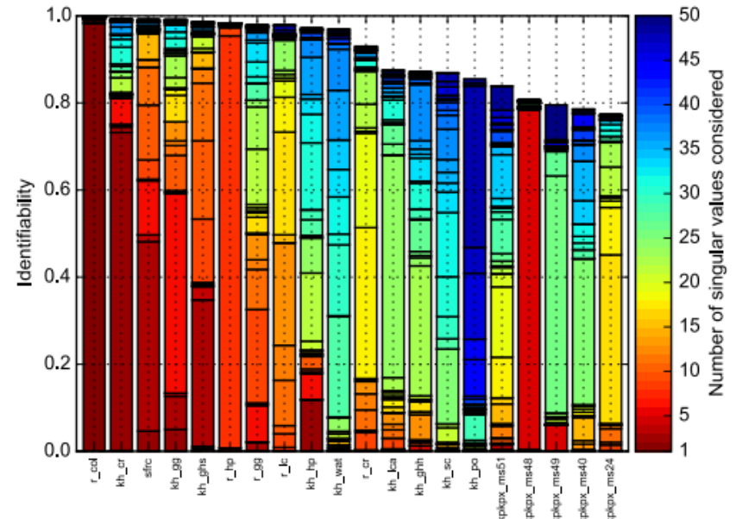
Figure 5. Stacked bar chart showing the 20 most identifiable parameters from a highly parameterized model, assuming a solution space of 50 singular values. The colors indicate identifiability that is gained by the addition of singular values to the solution space. For example, the recharge parameter on the far left is almost fully identifiable with only one singular value, therefore it is well-constrained by the observation data.

In highly parameterized models, however, the solution space may contain hundreds of singular values. In groundwater modeling, parameters are typically distributed spatially. In this case, identifiability may be better visualized on a map. PESTools can plot total identifiabilities (equivalent to the total height of the bars in Figure 5) spatially for a selected group of parameters. The location coordinates of each parameter are supplied to PESTools in csv format via a parameter information file (as shown above). Figure 6 shows the total identifiabilities for pilot points in zone 15:

tc = ip.ident_points.ix[ip.ident_points.zone == 15]
ip.plot_spatial(tc, nsingular=50)

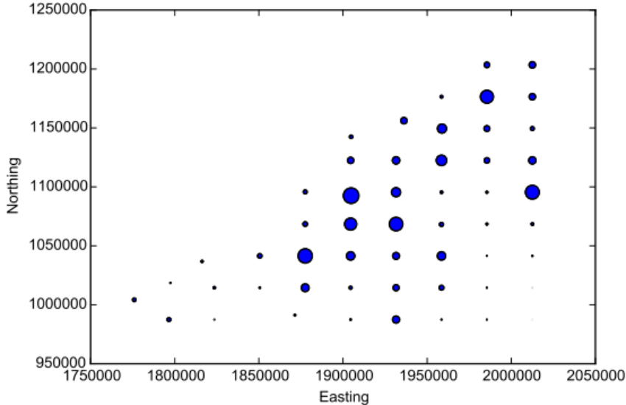

Figure 6. Map of pilot point total identifiability values for a given zone in a highly parameterized model. The large circles indicate identifiabilities close to 1; the smallest points indicate identifiabilities close to 0. Support for shapefile overlays on map figures is planned.

SUMMARY

PESTools is an open-source package aimed at leveraging the data analysis and visualization capabilities of Python to streamline parameter estimation workflows, allowing for deeper insight into model behavior, enhanced troubleshooting, and improved transparency in the calibration process. PESTtools is a work in progress. It can be downloaded at https://github.com/PESTools. We encourage contributions of code and examples, as well as feedback in the form of GitHub Issues.

Acknowledgments

Jeremey White, Mike Fienen, Jonathon Carter, and Dave Dahlstrom have all contributed to this project through development of code or testing datasets and concepts. Their participation in the project is greatly appreciated.

REFERENCES

Doherty, J., 2010a, PEST, Model-independent parameter estimation—User manual (5th ed., with slight additions): Brisbane, Australia, Watermark Numerical Computing, accessed November 13, 2014 at http://www.pesthomepage.org/.
Doherty, J., 2010b, PEST, Model Independent Parameter Estimation. Addendum to User Manual (5th Edition): Brisbane, Australia, Watermark Numerical Computing, accessed November 13, 2014 at http://www.pesthomepage.org/.
Doherty, J., and Hunt, R.J., 2009. Two statistics for evaluating parameter identifiability and error reduction, Journal of Hydrology 366 (2009), 119–127. doi:10.1016/j.jhydrol.2008.12.018
White, J.T., 2015. Pyemu: linear-based computer model uncertainty analyses. Accessed April 6, 2015, at https://github.com/jtwhite79/pyemu.

